Московский государственный технический университет им. Н.Э. Баумана

Факультет информатика и системы управления
Кафедра системы обработки информации и управления

Курс «Парадигмы и конструкции языков программирования» Отчет по домашнему заданию

Выполнил: | Проверил:
студент группы ИУ5-32Б: | преподаватель каф. ИУ5
Воронков А.Д. | Гапанюк Ю.Е.
Подпись и дата: | Подпись и дата:

Москва, 2025 г.
Текст программы
Файл paint.py

import sys
import sqlite3
import datetime as dt
from PyQt5.QtGui import QPixmap
from PyQt5 import uic
from PyQt5.QtWidgets import QApplication, QMainWindow
from PyQt5.QtGui import QPainter, QColor, QBrush, QPen
from PyQt5.QtCore import Qt, QPoint, QRect
from PyQt5.Qt import *

class List(QMainWindow):
def __init__(self):
super().__init__()
uic.loadUi('pr.ui', self)
self.load()

def load(self):
self.setWindowTitle('Paint')
self.kar = False
self.place = []
self.sc = QPoint()
self.fc = QPoint()
self.im = QPixmap()
self.size = 1
self.color = QColor(255, 255, 255)
self.color2 = QColor(0, 0, 0)
self.im.fill(self.color)
self.pushButton.clicked.connect(self.change_painter)
self.pushButton_4.clicked.connect(self.openim)
self.pushButton_2.clicked.connect(self.saveim)
self.pushButton_3.clicked.connect(self.new_image)
self.pushButton_5.setStyleSheet("background-color: {}".format(self.color.name()))
self.pushButton_10.setStyleSheet("background-color: {}".format(self.color2.name()))
self.pushButton_5.clicked.connect(self.change_color)
self.pushButton_10.clicked.connect(self.change_color2)
self.comboBox.addItem('1')
self.comboBox.addItem('2')
self.comboBox.addItem('3')
self.comboBox.addItem('4')
self.comboBox.addItem('5')
self.comboBox.addItem('6')
self.comboBox.addItem('7')
self.comboBox.addItem('8')
self.comboBox.addItem('9')
self.comboBox.addItem('10')
self.pushButton_6.clicked.connect(self.change_painter)
self.painter = 0
self.comboBox.activated[str].connect(self.change_size)
self.pushButton_8.clicked.connect(self.change_painter)
self.pushButton_7.clicked.connect(self.change_painter)
self.pushButton_9.clicked.connect(self.change_painter)
self.pushButton_11.clicked.connect(self.show_db)
self.maincolor = QColor(255, 255, 255)
self.las = False
self.kar = False
self.db = False

def save_to_db(self, p):
date = dt.datetime.now().date()
time = dt.datetime.now().time()
con = sqlite3.connect('pro_db.sqlite')
cur = con.cursor()
cur.execute(f"""INSERT INTO saves(Путь,Дата,Время) VALUES('Сохранено({str(p)})','{str(date)}','{str(time)}')""")
con.commit()
con.close()
self.show_db()
self.show_db()

def show_db(self):
if self.db:
self.stop_show()
else:
self.tableWidget = QTableWidget(self)
self.tableWidget.resize(330, 560)
self.tableWidget.move(780, 110)
con = sqlite3.connect('pro_db.sqlite')
cur = con.cursor()
res = cur.execute("""SELECT * from saves""").fetchall()
con.commit()
con.close()
self.tableWidget.setRowCount(len(res))
self.tableWidget.setColumnCount(3)
for i in range(len(res)):
for t in range(3):
self.tableWidget.setItem(i, t, QTableWidgetItem(res[i][t]))
self.tableWidget.show()
self.db = True

def stop_show(self):
self.tableWidget.deleteLater()
self.tableWidget = 0
self.db = False

def change_painter(self):
a = self.sender().text()
if a == 'Прямоугольник':
self.painter = self.draw_rect
self.las = False
self.kar = False
elif a == 'Линия':
self.painter = self.draw_line
self.las = False
self.kar = False
elif a == 'Эллипс':
self.painter = self.draw_ellipse
self.las = False
self.kar = False
elif a == 'Ластик':
self.painter = self.lastik
self.las = True
self.kar = False
elif a == 'Карандаш':
self.painter = self.karandash
self.las = False
self.kar = True

def change_color(self):
color = QColorDialog.getColor()
self.color = color
self.pushButton_5.setStyleSheet("background-color: {}".format(self.color.name()))

def change_color2(self):
color = QColorDialog.getColor()
self.color2 = color
self.pushButton_10.setStyleSheet("background-color: {}".format(self.color2.name()))

def change_size(self):
t = self.comboBox.currentText()
self.size = int(t)

def karandash(self, p):
p = QPainter(self.im)
p.setBrush(self.color2)
pen = QPen(self.color2)
pen.setWidth(self.size)
p.setPen(pen)

# Проблема здесь - self.size / 2 дает float
# Исправляем на целочисленное деление или int()
x = self.fc.x() - 50 - self.size // 2 # или int(self.size / 2)
y = self.fc.y() - 150 - self.size // 2
x2 = self.fc.x() - 50 + self.size // 2
y2 = self.fc.y() - 150 + self.size // 2

a1 = QPoint(x, y)
a2 = QPoint(x2, y2)
rect = QRect(a1, a2)
p.drawEllipse(rect)

def new_image(self):
self.im = QPixmap(500, 500)
self.im.fill(self.color)
self.maincolor = self.color
self.update()

def saveim(self):
a = QFileDialog.getSaveFileName(self, 'Выбрать файл', '')[0]
self.im.save(a)
self.save_to_db(a)

def openim(self):
a = QFileDialog.getOpenFileName(self, 'Выбрать картинку', '')[0]
self.im = QPixmap(a)
self.update()

def paintEvent(self, event):
qp = QPainter(self)
qp.drawPixmap(50, 150, self.im)
if self.las or self.kar:
self.painter(qp)
qp.setBrush(self.color)
pen = QPen(self.color2)
pen.setWidth(self.size)
qp.setPen(pen)
if self.painter != 0:
self.painter(qp)

def lastik(self, p):
p = QPainter(self.im)
p.setBrush(self.maincolor)
pen = QPen(self.maincolor)
pen.setWidth(self.size)
p.setPen(pen)
a1 = QPoint(self.fc.x() - 50 - self.size, self.fc.y() - 150 - self.size)
a2 = QPoint(self.fc.x() - 50 + self.size, self.fc.y() - 150 + self.size)
rect = QRect(a1, a2)
p.drawRect(rect)

def draw_rect(self, qp, a1=0, a2=0):
if a1 == 0:
rect = QRect(self.sc, self.fc)
else:
rect = QRect(a1, a2)
qp.drawRect(rect)

def draw_ellipse(self, qp, a1=0, a2=0):
if a1 == 0:
rect = QRect(self.sc, self.fc)
else:
rect = QRect(a1, a2)
qp.drawEllipse(rect)

def draw_line(self, qp, a1=0, a2=0):
if a1 == 0:
line = QLine(self.sc, self.fc)
else:
line = QLine(a1, a2)
qp.drawLine(line)

def mousePressEvent(self, event):
if self.painter != 0 and event.button() == Qt.LeftButton:
a = event.pos()
self.sc = event.pos()
self.fc = event.pos()
self.update()

def mouseMoveEvent(self, event):
if self.painter != 0:
self.fc = event.pos()
self.update()

def mouseReleaseEvent(self, event):
if self.painter != 0 and event.button() == Qt.LeftButton and not self.las and not self.kar:
p = QPainter(self.im)
p.setBrush(self.color)
pen = QPen(self.color2)
pen.setWidth(self.size)
p.setPen(pen)
a1 = QPoint(self.sc.x() - 50, self.sc.y() - 150)
a2 = QPoint(self.fc.x() - 50, self.fc.y() - 150)
self.painter(p, a1=a1, a2=a2)
self.sc = QPoint()
self.fc = QPoint()

if __name__ == '__main__':
app = QApplication(sys.argv)
form = List()
form.show()
sys.exit(app.exec_())

Файл pr.ui

<?xml version="1.0" encoding="UTF-8"?>
<ui version="4.0">
<class>MainWindow</class>
<widget class="QMainWindow" name="MainWindow">
<property name="geometry">
<rect>
<x>0</x>
<y>0</y>
<width>900</width>
<height>700</height>
</rect>
</property>
<property name="windowTitle">
<string>Paint</string>
</property>
<widget class="QWidget" name="centralwidget">
<layout class="QVBoxLayout" name="verticalLayout">
<item>
<widget class="QWidget" name="widget" native="true">
<layout class="QHBoxLayout" name="horizontalLayout_2">
<item>
<widget class="QPushButton" name="pushButton">
<property name="text">
<string>Прямоугольник</string>
</property>
<property name="minimumSize">
<size>
<width>100</width>
<height>30</height>
</size>
</property>
</widget>
</item>
<item>
<widget class="QPushButton" name="pushButton_6">
<property name="text">
<string>Линия</string>
</property>
<property name="minimumSize">
<size>
<width>100</width>
<height>30</height>
</size>
</property>
</widget>
</item>
<item>
<widget class="QPushButton" name="pushButton_7">
<property name="text">
<string>Эллипс</string>
</property>
<property name="minimumSize">
<size>
<width>100</width>
<height>30</height>
</size>
</property>
</widget>
</item>
<item>
<widget class="QPushButton" name="pushButton_8">
<property name="text">
<string>Ластик</string>
</property>
<property name="minimumSize">
<size>
<width>100</width>
<height>30</height>
</size>
</property>
</widget>
</item>
<item>
<widget class="QPushButton" name="pushButton_9">
<property name="text">
<string>Карандаш</string>
</property>
<property name="minimumSize">
<size>
<width>100</width>
<height>30</height>
</size>
</property>
</widget>
</item>
<item>
<spacer name="horizontalSpacer_3">
<property name="orientation">
<enum>Qt::Horizontal</enum>
</property>
<property name="sizeHint">
<size>
<width>20</width>
<height>20</height>
</size>
</property>
</spacer>
</item>
<item>
<widget class="QLabel" name="label">
<property name="text">
<string>Толщина:</string>
</property>
</widget>
</item>
<item>
<widget class="QComboBox" name="comboBox">
<property name="minimumSize">
<size>
<width>60</width>
<height>30</height>
</size>
</property>
</widget>
</item>
<item>
<spacer name="horizontalSpacer_4">
<property name="orientation">
<enum>Qt::Horizontal</enum>
</property>
<property name="sizeHint">
<size>
<width>20</width>
<height>20</height>
</size>
</property>
</spacer>
</item>
<item>
<widget class="QLabel" name="label_2">
<property name="text">
<string>Цвет линии:</string>
</property>
</widget>
</item>
<item>
<widget class="QPushButton" name="pushButton_10">
<property name="minimumSize">
<size>
<width>30</width>
<height>30</height>
</size>
</property>
<property name="styleSheet">
<string notr="true">background-color: rgb(0, 0, 0); border: 1px solid gray;</string>
</property>
<property name="text">
<string/>
</property>
</widget>
</item>
<item>
<widget class="QLabel" name="label_3">
<property name="text">
<string>Цвет заливки:</string>
</property>
</widget>
</item>
<item>
<widget class="QPushButton" name="pushButton_5">
<property name="minimumSize">
<size>
<width>30</width>
<height>30</height>
</size>
</property>
<property name="styleSheet">
<string notr="true">background-color: rgb(255, 255, 255); border: 1px solid gray;</string>
</property>
<property name="text">
<string/>
</property>
</widget>
</item>
</layout>
</widget>
</item>
<item>
<widget class="QWidget" name="widget_2" native="true">
<layout class="QHBoxLayout" name="horizontalLayout_3">
<item>
<widget class="QPushButton" name="pushButton_4">
<property name="text">
<string>Открыть</string>
</property>
<property name="minimumSize">
<size>
<width>100</width>
<height>30</height>
</size>
</property>
</widget>
</item>
<item>
<widget class="QPushButton" name="pushButton_2">
<property name="text">
<string>Сохранить</string>
</property>
<property name="minimumSize">
<size>
<width>100</width>
<height>30</height>
</size>
</property>
</widget>
</item>
<item>
<widget class="QPushButton" name="pushButton_3">
<property name="text">
<string>Новое</string>
</property>
<property name="minimumSize">
<size>
<width>100</width>
<height>30</height>
</size>
</property>
</widget>
</item>
<item>
<widget class="QPushButton" name="pushButton_11">
<property name="text">
<string>Показать БД</string>
</property>
<property name="minimumSize">
<size>
<width>100</width>
<height>30</height>
</size>
</property>
</widget>
</item>
<item>
<spacer name="horizontalSpacer_5">
<property name="orientation">
<enum>Qt::Horizontal</enum>
</property>
<property name="sizeHint">
<size>
<width>40</width>
<height>20</height>
</size>
</property>
</spacer>
</item>
</layout>
</widget>
</item>
<item>
<widget class="QFrame" name="frame">
<property name="frameShape">
<enum>QFrame::Box</enum>
</property>
<property name="frameShadow">
<enum>QFrame::Sunken</enum>
</property>
<property name="lineWidth">
<number>2</number>
</property>
<layout class="QVBoxLayout" name="verticalLayout_2">
<item>
<spacer name="verticalSpacer">
<property name="orientation">
<enum>Qt::Vertical</enum>
</property>
<property name="sizeHint">
<size>
<width>20</width>
<height>40</height>
</size>
</property>
</spacer>
</item>
</layout>
</widget>
</item>
</layout>
</widget>
</widget>
<resources/>
<connections/>
</ui>

Скриншот работы приложения

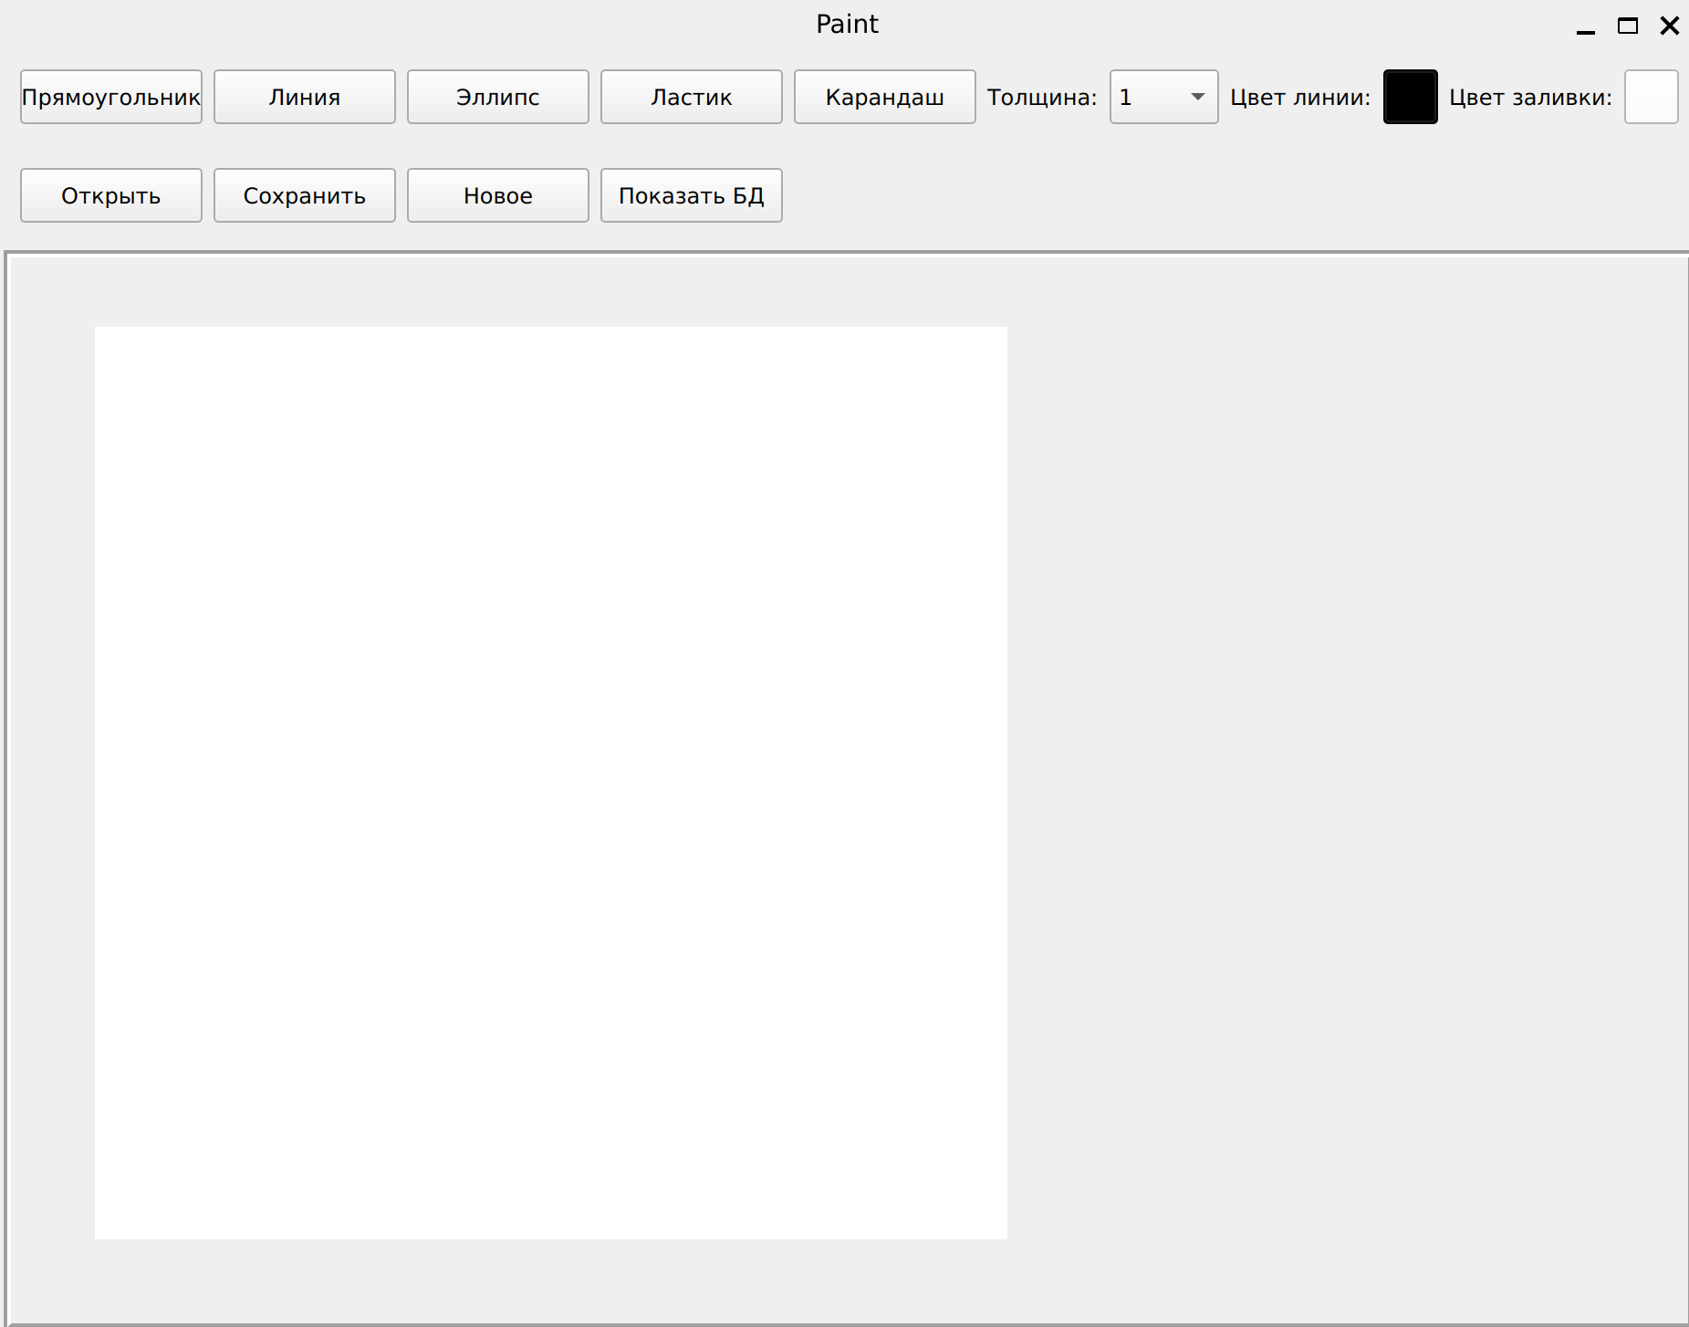
Рис. 1. Работа программы

